Table of Contents

1. Feature Specification Overview 3

1.1 Feature Description 3

2. Use Case: Terms & Conditions Signature Capture 3

2.1 Feature Flow 3

2.2 Preconditions 3

2.3 Main Flow 3

3. Use Case: Consolidated Terms & Conditions Signature Capture 4

3.1 Feature Flow 4

3.2 Preconditions 4

3.3 Main Flow 4

4. Use Case: Device Terms & Signature Capture 5

4.1 Feature Flow 5

4.2 Preconditions 5

4.3 Main Flow 5

4.4 Special Requirements 6

5. Use Case: PINPad Terms & Signature Capture 7

5.1 Feature Flow 7

5.2 Preconditions 7

5.3 Main Flow 8

5.4 Alternate Flow 8

5.5 Special Requirements 8

6. Use Case: Tender Signature Capture 9

6.1 Feature Flow 9

6.2 Preconditions 9

6.3 Main Flow 9

6.4 Alternate Flow 10

6.5 Special Requirements 11

7. Other feature Impacts 11

7.1 Tax Exempt Feature 11

7.2 Warranty Feature 11

7.3 Sale Feature 11

7.4 Suspend Feature 11

7.5 Total Processing Feature 11

8. Assumptions 11

9. Screen Layouts 12

9.1 POS Screens 12

9.2 Signature Capture Device 21

10. Printing 23

10.1 Receipt Changes 23

11. Configurable Settings 23

12. Logging Changes 23

12.1 Data Output 23

13. Interface 23

14. Out Of Scope 23

15. Business Sign Off 24

16. Technical Sign Off 24

17. Technical Review 24

18. Technical Inform 24

19. Revision History 25

19.1 Reviews 25

19.2 Revision History 25

20. Referenced documentation 25

Feature Specification Overview

## Feature Description

The Signature Capture with Terms feature allows the retailer to setup different actions to require a customer signature before the action can be completed. Additionally, Terms and Conditions prompts (e.g. selling a warranty item) can be setup for a signature reason that requires customer acceptance before the action can be completed.

# Use Case: Terms & Conditions Signature Capture

## Feature Flow



Figure : Terms & Conditions Signature Capture Process Flow

## Preconditions

* An item requires acceptance of terms and conditions and/or signature.

## Main Flow

1. The system evaluates the consolidation flag on the item requesting a signature.
2. If the consolidation flag is enabled for the action, the system stores the signature request to be prompted during Total Processing use case, the use case ends and the system returns to the calling use case with completed status.
3. The system evaluates the PINPad Flag (section 11).
4. If the flag is set, system executes Use Case: PINPad Terms & Signature Capture (section 5).
5. If the flag is not set, system executes Use Case: Device Terms & Signature Capture (section 4).
6. If the executed use case returns with Not Completed status, the use case ends and the system returns to the calling use case with a not completed status
7. If the executed use case returns with a Completed status, the use case ends and the system returns to the calling use case with a completed status.

# Use Case: Consolidated Terms & Conditions Signature Capture

## Feature Flow



Figure : Consolidated Signature Process Flow

## Preconditions

* Item(s) requiring consolidated acceptance of terms and conditions and/or signature stored information.
* Total has been selected.

## Main Flow

1. The system evaluates the PINPad Flag (section 11).
2. If the flag is set, system executes Use Case: PINPad Terms & Signature Capture (section 5).
3. If the flag is not set, system executes Use Case: Device Terms & Signature Capture (section 4).
4. If the executed use case returns with Not Completed status, the use case ends and the system returns to the calling use case with a not completed status
5. If the executed use case returns with a Completed status, the use case ends and the system returns to the calling use case with a completed status.

# Use Case: Device Terms & Signature Capture

## Feature Flow



Figure : Device Terms & Signature Capture Process Flow

## Preconditions

* System determined to capture terms & signatures on device.

## Main Flow

1. The system determines if Terms & Conditions are required.
2. If Terms & Conditions are not required, system continues with bullet 6 below.
3. System displays the Terms and Conditions (or list of Terms & Conditions if consolidated) and prompts for.
4. The operator accepts or declines the Terms and Conditions.
5. If the Terms and Conditions are declined, the system displays Terms & Conditions Not Accepted Message (section 9.1.6.4), the operator acknowledges the message and the use case ends and returns to the calling use case with a not completed status.
6. The system determines if Signature(s) is required.
7. If signature is not required, the use case ends and returns to the calling use case with a completed status.
8. The system prompts the user to obtain a signature from the customer.
9. If the user selects to Clear the signature, the system refreshes the screen, the signature is removed and the system returns to bullet 8 above.
10. If the user selects to abort, the system Terms & Conditions Not Accepted Message (section 9.1.6.4), the operator acknowledges the message and the use case ends and returns to the calling use case with a not completed status.
11. The customer signs the device and accepts the entry.
12. If the user accepts the entry and fails to provide the required signature, the system displays an Invalid Signature Message (section 9.1.6.2), the operator acknowledges the message and the system returns to bullet 8 above.
13. The system validates the signature by validating against minimum required length.
14. If the signature does not meet the minimum required length criteria, the system displays an Invalid Signature Message (section 9.1.6.2), the operator acknowledges the message, the signature is cleared and the system returns to bullet 8 above.
15. If the signature meets the minimum required length criteria, the system logs the signature captured and the reason for the signature.
16. The use case ends and the system returns to the calling use case.

## Special Requirements

1. If Terms and Conditions are not defined in the database, the system displays only the signature reason.
2. Terms and Conditions and signature prompt occurs after any additional information for the item or transaction has been captured.
3. The signature capture screen contains the reason for the signature. If the signature reason has Terms and Conditions defined, the signature reason is expandable to display the Terms and Conditions and the Yes/No check boxes are enabled.
4. Minimum required length of a signature is not parameterized but a standard 50 pts.
5. If multiple instances of the same signature reason occur in the transaction, the system considers each one as a separate instance. For example, if three PSP-Warranty items are sold, each one is considered a separate signature request and each will require acceptance of Terms and Conditions (if applicable). If signature is consolidated for the reason, each instance will display separate Signature Reason with Terms and Conditions lines.

# Use Case: PINPad Terms & Signature Capture

## Feature Flow



Figure : PINPad Terms & Signature Capture Process Flow

## Preconditions

* System determined to capture terms & signatures on PINPad.

## Main Flow

1. System evaluates if PINPad is associated with the device.
2. If no PINPad associated, system executes Associate PINPad with Device Alternate Flow (section 5.4.1).
3. If PINPad is not successfully associated to device, system executes PINPad Association Fail Alternate Flow (section 5.4.2). **NOTE**: Not successful could be PINPad is busy with another device transaction or not functioning. Busy functionality is controlled by MRF, not Authorizer.
4. If PINPad is successfully associated to device, system sends signature capture data to PINPad.
5. If response from PINPad is success, system logs the signature captured and the reason for the signature, sets the status to Completed, the use case ends and system returns to the calling use case.
6. If the response from PINPad is not success, system displays Terms & Conditions Not Accepted Message (section 9.1.6.4).
7. After user acknowledges message, system sets status to Not Completed.
8. The use case ends and the system returns to the calling use case.

## Alternate Flow

### Associate PINPad with Device Alternate Flow

1. System prompts user to associate PINPad.
2. If user scans a payment station or a PINPad barcode, system evaluates success of association and returns status to calling use case.
3. If user selects back (option not available during tender), system displays Remove Items Prompt (section 9.1.6.8) and continues with PINPad Association Fail Alternate Flow (section 5.4.2) bullet 7.
4. If user places device in a docking station, system evaluates success of docking.
5. If dock is successful, system returns success status to calling use case.
6. If dock is not successful, user selects dock option on screen and system returns success status to calling use case.

### PINPad Association Fail Alternate Flow

1. The system evaluates the Fail on Device Flag (section 11).
2. If the Flag is set, system executes Use Case: Device Terms & Signature Capture (section 4).
3. If Flag is not set, system displays Retry, Abort or Print Prompt Message (section 9.1.6.6).
4. If User selects Retry, System restarts Associate PINPad with Device Alternate Flow (section 5.4.1).
5. If User selects Print, system executes process to associate printer to the device, prints the Terms and Conditions Receipt and logs the manual signature indicator, signature captured and the reason for the signature, sets status to Completed and returns to Main Flow bullet 8.
6. If user selects Abort, system displays Remove Items Prompt (section 9.1.6.8).
7. If user selects No, System restarts Associate PINPad with Device Alternate Flow (section 5.4.1).
8. If user selects Yes, System sets status to Not Completed and returns to Main Flow bullet 8.

## Special Requirements

1. If Terms and Conditions are not defined in the database, the system displays only the signature reason.
2. Terms and Conditions and signature prompt occurs after any additional information for the item or transaction has been captured.
3. The signature capture screen contains the reason for the signature. If the signature reason has Terms and Conditions defined, the signature reason is expandable to display the Terms and Conditions and the Yes/No check boxes are enabled.
4. Minimum required length of a signature is not parameterized but a standard 50 pts.
5. If multiple instances of the same signature reason occur in the transaction, the system considers each one as a separate instance. For example, if three PSP-Warranty items are sold, each one is considered a separate signature request and each will require acceptance of Terms and Conditions (if applicable). If signature is consolidated for the reason, each instance will display separate Signature Reason with Terms and Conditions lines.

# Use Case: Tender Signature Capture

## Feature Flow



Figure : Tender Signature Process Flow

## Preconditions

* Signature required for a tender.

## Main Flow

1. The system evaluates if a manual signature has been captured previously in the transaction.
2. If a previous manual signature has been captured, system executes Previous Manual Signature Alternate Flow (section 6.4.1).
3. The system evaluates the PINPad Flag (section 11).
4. If the Flag is set, system executes Capture Tender Signature on PINPad Alternate Flow (section 6.4.2).
5. The system prompts the operator to obtain a signature from the customer.
6. The customer signs the device and accepts the entry.
7. If the operator selects to clear the signature, the system refreshes the screen, the signature is removed and the system restarts the Main Flow.
8. If user selects ‘Print/Abort’, system executes process to associate printer to the device, prints the Tender Signature Receipt and logs the manual signature indicator, signature captured and the reason for the signature, sets status to Success, the use case ends and system returns to calling use case.
9. If the operator accepts the entry and fails to provide the required signature, the system displays an Invalid Signature Message (section 9.1.6.2), the operator acknowledges the message and the system returns to bullet 5 above.
10. The system validates the signature by validating against minimum required length.
11. If the signature does not meet the minimum required length criteria, the system displays an Invalid Signature Message (section 9.1.6.2), the operator acknowledges the message, the signature is cleared and the system returns to bullet 5 above.
12. If the signature meets the minimum required length criteria, the system logs the signature captured and the reason for the signature and sets status to Success.
13. The use case ends and the system returns to the calling use case.

## Alternate Flow

### Previous Manual Signature Alternate Flow

1. System displays Manual Signature Captured Prompt (section 9.1.6.1).
2. The system logs the manual signature indicator, signature captured and the reason for the signature
3. The use case ends and system returns to the calling use case.

### Capture Tender Signature on PINPad Alternate Flow

1. System evaluates if PINPad is associated with the device.
2. If no PINPad associated, system executes Associate PINPad with Device Alternate Flow (section 5.4.1).
3. If PINPad is not successfully associated to device, system executes Tender PINPad Association Fail Alternate Flow (section 6.4.4).
4. If PINPad is successfully associated to device, system sends signature capture flag to PINPad.
5. If response from PINPad is success, system logs the signature captured and the reason for the signature and the use case ends and system returns to the calling use case.
6. System displays Retry or Print Prompt Message (section 9.1.6.3).
7. If user selects ‘Retry’, system returns to bullet 4 above.
8. If user selects ‘Print’, system executes process to associate printer to the device, prints the Tender Signature Receipt and logs the manual signature indicator, signature captured and the reason for the signature, sets status to Success and returns to Main Flow bullet 13.

### Abort Tender Signature Alternate Flow

1. System evaluates the Manual Signature Flag (section 11).
2. If flag is not set, system returns to Main Flow bullet 5.
3. If the flag is set, system prints Tender Signature Receipt and logs the manual signature indicator, signature captured and the reason for the signature, sets status to Success and returns to Main Flow bullet 13.

### Tender PINPad Association Fail Alternate Flow

1. The system evaluates the Fail on Device Flag (section 11).
2. Capture Tender Signature on PINPad Alternate Flow6.4.26
3. If the Flag is set, system displays Sign on Device, Retry or Print Prompt Message (section 9.1.6.7).
4. If user selects Sign on device, system executes Use Case: Device Terms & Signature Capture (section 4).
5. If user selects Retry, System returns to Capture Tender Signature on PINPad Alternate Flow (section 6.4.2), bullet 4.
6. If user selects Print, system returns to Capture Tender Signature on PINPad Alternate Flow (section 6.4.2), bullet 8.

## Special Requirements

1. The signature capture screen contains the reason for the signature.
2. Minimum required length of a signature is not parameterized but a standard 50 pts.
3. If multiple instances of the same signature reason occur in the transaction, the system considers each one as a separate instance. For example, if three credit card tenders are added, each one is considered a separate signature request and each will require signature. If signature is consolidated for the tender, each instance will display separate Signature Reason line.
4. The terms and conditions to display for Finance Tender are the terms defined for the selected Finance Plan.

# Other feature Impacts

## Tax Exempt Feature

The Tax Exempt use case is updated to check if the process requires signature to continue with the transaction process. A separate parameter is setup for Item and Transaction Tax Exempt.

## Warranty Feature

The Warranty use case is updated to check if the process requires signature to continue with the warranty process for the PSP and PRP item types.

## Sale Feature

The Sale use case is updated to check for terms and signatures during the item processing

## Suspend Feature

The Suspend Use Case is updated to reflect that any signatures captured prior to suspend or any actions that occur prior to suspend that require a signature will be stored so that upon resuming transaction the signatures logged

## *Total Processing Feature*

The Total Processing use case is updated to check for consolidated signatures during the total processing.

# Assumptions

1. All text displayed by the system is configurable by brand to support multi-language.  Text is defined from an external source or defined within the system.

# Screen Layouts

## POS Screens

### Terms and Conditions Screen

This screen appears when an action requires acceptance of terms and conditions. The action may require the signature to be captured at the time the action is completed.

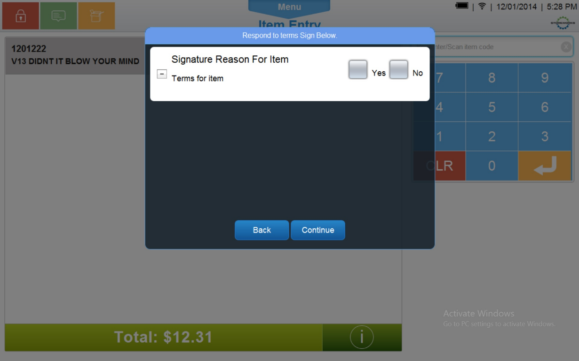

Figure : Terms and Conditions

#### Screen Definitions

##### Instruction Text

|  |
| --- |
| **Instructions – Text is configurable** |
| Respond to terms Sign Below. |

##### Navigation/Menu Keys

| **Label** | **State** | **Next Screen** | **Notes** |
| --- | --- | --- | --- |
| Back | Enabled | * Calling use case with action not completed | None |
| Continue | Enabled | All Terms accepted:   * Signature with Terms and Conditions Screen (section 0)   At least one Terms not accepted:   * Terms & Conditions Not Accepted Message (section 0) | None |
| Expand/Collapse | See Notes | * See Notes | The +/- are displayed only when a signature reason has Terms and Conditions associated with it.  Only one Terms and Conditions can be expanded at a time. As the + next to the Terms and Conditions, the Terms and Conditions for that line are displayed and any other terms are collapsed. |

##### Data/Input Field Enhancements

| **Label** | **Editable** | **Req’d?** | **Data Type** | **Min**  **Length** | **Max**  **Length** | **Notes** |
| --- | --- | --- | --- | --- | --- | --- |
| <Signature Reason> | No | N/A | N/A | N/A | N/A | For each signature reason to be captured, the descriptive text for each signature is displayed on the line (for example ‘Transaction Tax Exempt’). If the signature reason is for an item, the item description is displayed with the Signature Reason (for example ‘Item Tax Exempt: Brand Laptop’).  If the signature has Terms and Conditions, the +/- is present and once expanded the Terms and Conditions are displayed for the particular signature. |
| Yes/No | See Notes | See Notes | Check Box | N/A | N/A | The Yes/No option is only displayed and required when the signature reason has Terms and Conditions defined for it.  Either the Yes or the No needs to be selected for each line. Only one check box per line can be checked at a time. |

##### Reason Code Enhancements

|  |  |  |
| --- | --- | --- |
| **Reason Code** | **Valid Values** | **Default Value** |
| None |  |  |

### Signature with Terms and Conditions Screen

This screen appears when terms and conditions requires a signature.

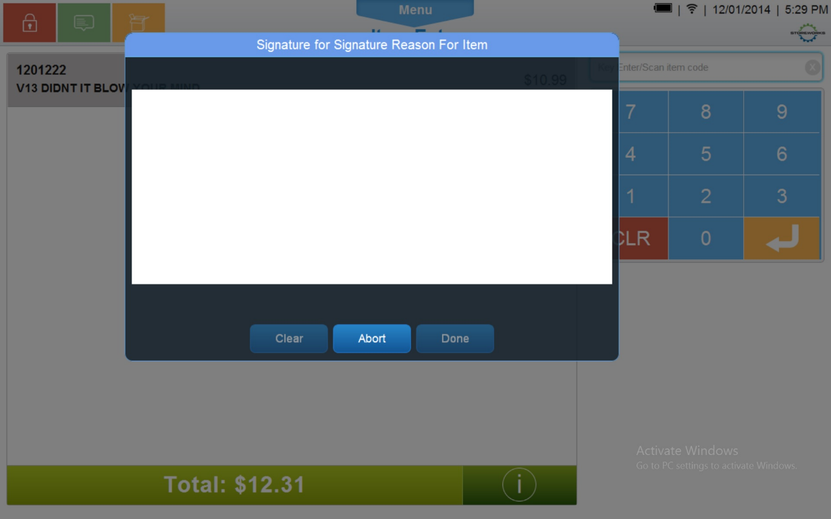

Figure : Signature with Terms and Conditions

#### Screen Definitions

##### Instruction Text

|  |
| --- |
| **Instructions – Text is configurable** |
| Signature for <Signature Reason> for Item. |

##### Navigation/Menu Keys

| **Label** | | **State** | | **Next Screen** | | **Notes** |
| --- | --- | --- | --- | --- | --- | --- |
| Done | See Note | | * Signature capture does not meet minimum length or required data is missing: Invalid Signature Message (section 9.1.6.2). * Signature capture meets minimum length: calling use case | | Enabled when an entry is made. | |
| Clear | See Note | | * Signature Capture | | Enabled when an entry is made. | |
| Abort | See Note | | * Sale Use Case | | None | |

##### Data/Input Field Enhancements

| **Label** | **Editable** | **Req’d?** | **Data Type** | **Min**  **Length** | **Max**  **Length** | **Notes** |
| --- | --- | --- | --- | --- | --- | --- |
| <Signature Reason> | No | N/A | N/A | N/A | N/A | For each signature reason to be captured, the descriptive text for each signature is displayed on the line (for example ‘Transaction Tax Exempt’). If the signature reason is for an item, the item description is displayed with the Signature Reason (for example ‘Item Tax Exempt: Brand Laptop’). |
| Signature Line | Yes | Yes | N/A | See Notes | N/A | Database parameter to define the minimum data points allowed. |

##### Reason Code Enhancements

|  |  |  |
| --- | --- | --- |
| **Reason Code** | **Valid Values** | **Default Value** |
| None |  |  |

### Consolidated Terms and Conditions Screen

This screen appears when an action requires acceptance of multiple terms and conditions. The action may require the signature to be captured at the time the action is completed.

If a terms and conditions is selected, it is expanded to display the inventory details. If the expanded terms and conditions is selected again, the details are collapsed. If another terms and conditions is selected, the previous item details are collapsed and the selected terms and conditions is expanded.

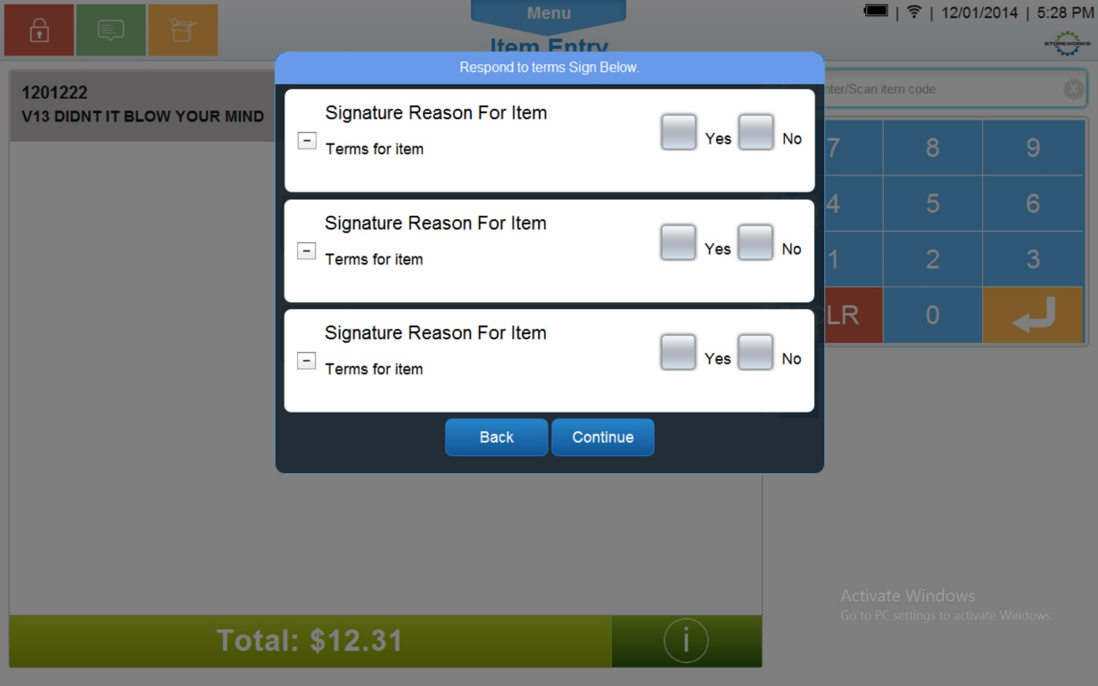

Figure : Consolidated Terms and Conditions

#### Screen Definitions

##### Instruction Text

|  |
| --- |
| **Instructions – Text is configurable** |
| Respond to terms Sign Below. |

##### Navigation/Menu Keys

| **Label** | **State** | **Next Screen** | **Notes** |
| --- | --- | --- | --- |
| Back | Enabled | * Calling use case with action not completed | None |
| Continue | Enabled | * All Terms accepted: Consolidated Signature with Terms and Conditions Screen (section 9.1.4)   At least one Terms not accepted:   * Terms & Conditions Not Accepted Message (section 0) | None |
| Expand/Collapse | See Notes | * See Notes | The +/- are displayed only when a signature reason has Terms and Conditions associated with it.  Only one Terms and Conditions can be expanded at a time. As the + next to the Terms and Conditions, the Terms and Conditions for that line are displayed and any other terms are collapsed. |

##### Data/Input Field Enhancements

| **Label** | **Editable** | **Req’d?** | **Data Type** | **Min**  **Length** | **Max**  **Length** | **Notes** |
| --- | --- | --- | --- | --- | --- | --- |
| <Signature Reason> | No | N/A | N/A | N/A | N/A | For each signature reason to be captured, the descriptive text for each signature is displayed on the line (for example ‘Transaction Tax Exempt’). If the signature reason is for an item, the item description is displayed with the Signature Reason (for example ‘Item Tax Exempt: Brand Laptop’).  If the signature has Terms and Conditions, the +/- is present and once expanded the Terms and Conditions are displayed for the particular signature. |
| Yes/No | See Notes | See Notes | Check Box | N/A | N/A | The Yes/No option is only displayed and required when the signature reason has Terms and Conditions defined for it.  Either the Yes or the No needs to be selected for each line. Only one check box per line can be checked at a time. |

##### Reason Code Enhancements

|  |  |  |
| --- | --- | --- |
| **Reason Code** | **Valid Values** | **Default Value** |
| None |  |  |

### Consolidated Signature with Terms and Conditions Screen

This screen appears when a consolidated action requires a signature. The action may require the signature to be captured at the time the action is completed.

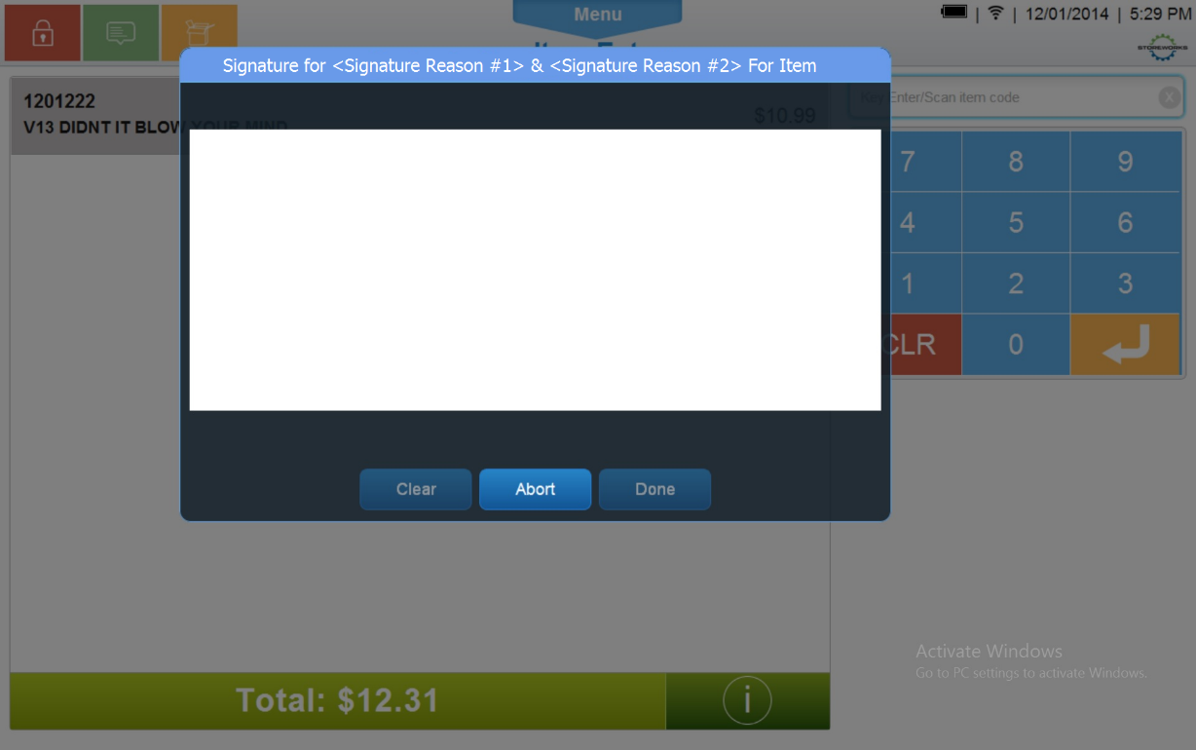

Figure : Consolidated Signature with Terms and Conditions

#### Screen Definitions

##### Instruction Text

|  |
| --- |
| **Instructions – Text is configurable** |
| Signature for <Signature Reason #1> & <Signature Reason #2> for Item. |

##### Navigation/Menu Keys

| **Label** | | **State** | **Next Screen** | **Notes** |
| --- | --- | --- | --- | --- |
| Done | See Note | | * Signature capture does not meet minimum length or required data is missing: Invalid Signature Message (section 9.1.6.2). * Signature capture meets minimum length: calling use case | Enabled when an entry is made. |
| Clear | See Note | | * Signature Capture | Enabled when an entry is made. |
| Abort | See Note | | * Sale Use Case | None |

##### Data/Input Field Enhancements

|  |  |  |  |  |  |  |
| --- | --- | --- | --- | --- | --- | --- |
| **Label** | **Editable** | **Req’d?** | **Data Type** | **Min**  **Length** | **Max**  **Length** | **Notes** |
| <Signature Reason> | No | N/A | N/A | N/A | N/A | For each signature reason to be captured, the descriptive text for each signature is displayed on the line (for example ‘Transaction Tax Exempt’). If the signature reason is for an item, the item description is displayed with the Signature Reason (for example ‘Item Tax Exempt: Brand Laptop’). |
| Signature Line | Yes | Yes | N/A | See Notes | N/A | Database parameter to define the minimum data points allowed. |

##### Reason Code Enhancements

|  |  |  |
| --- | --- | --- |
| **Reason Code** | **Valid Values** | **Default Value** |
| None |  |  |

### Tender Signature Screen

This screen appears when a tender requires a signature.

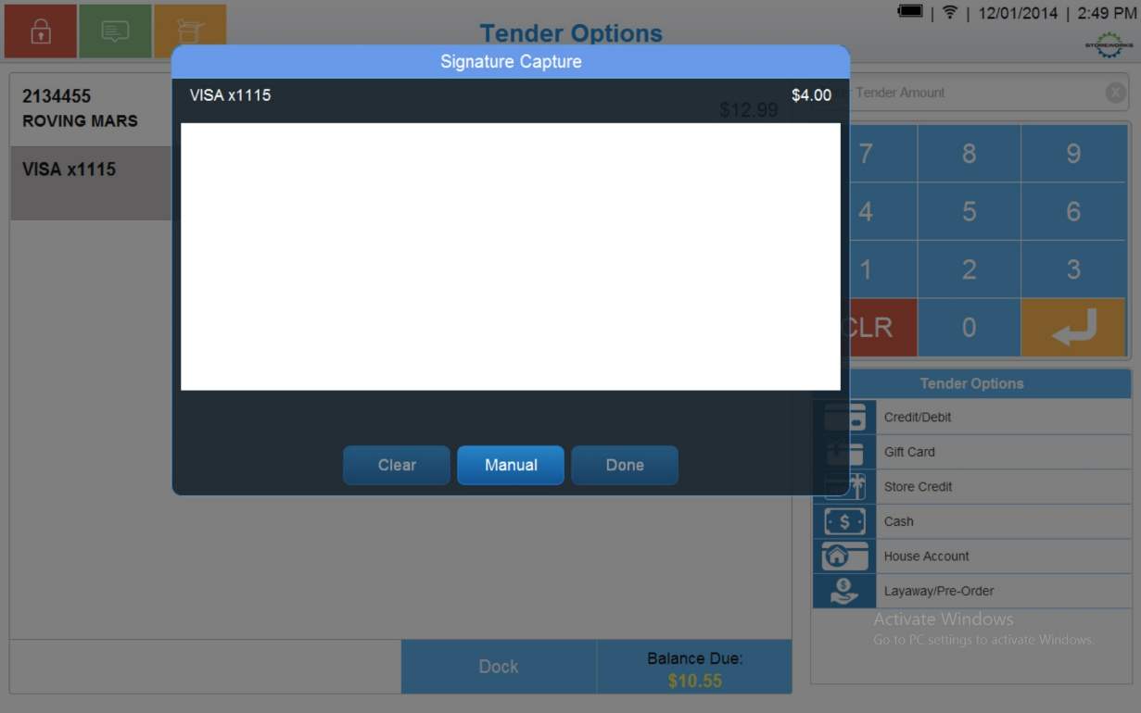

Figure : Consolidated Signature with Terms and Conditions

#### Screen Definitions

##### Instruction Text

|  |
| --- |
| **Instructions – Text is configurable** |
| Signature Capture  Credit Tender – “<Card Type> Credit <last 4 digits>” and “Total Credit Amt: $<tender amt>” |

##### Navigation/Menu Keys

| **Label** | **State** | **Next Screen** | **Notes** |
| --- | --- | --- | --- |
| Done | See Note | * Signature capture does not meet minimum length or required data is missing: Invalid Signature * Signature capture meets minimum length: calling use case | Enabled when an entry is made. |
| Clear | See Note | * Signature Capture | Enabled when an entry is made. |
| Manual | See Note | * Capture Signature Manually | Displayed only if the Manual Signature Allowed for Tender parameter is enabled. |

##### Data/Input Field Enhancements

|  |  |  |  |  |  |  |
| --- | --- | --- | --- | --- | --- | --- |
| **Label** | **Editable** | **Req’d?** | **Data Type** | **Min**  **Length** | **Max**  **Length** | **Notes** |
| N/A | Yes | Yes | N/A | N/A | N/A | None |

##### Reason Code Enhancements

|  |  |  |
| --- | --- | --- |
| **Reason Code** | **Valid Values** | **Default Value** |
| None |  |  |

### Dialog Messages/Message Boxes

#### Manual Signature Captured Prompt

|  |  |
| --- | --- |
| **Description** | When manual signature captured previously for a tender, message prompts. |
| **Message** | Manual Signature Previously Captured. |
| **Key prompt** | OK – Continues to next screen |
| **Notes** | Text is configurable. |

#### Invalid Signature Message

|  |  |
| --- | --- |
| **Description** | The Invalid Data Notice informs the operator that the data entered in the required fields is invalid (e.g. incorrect format, missing). The <ARG> described in the Message is replaced with the name of the data field that contains the invalid data. If there are multiple data fields with invalid data, the system only displays the name of the first data field with invalid data. Upon acknowledging the message, the system returns to the previous screen. |
| **Message** | The following field has invalid data: <ARG>. Please correct the invalid data. |
| **Key prompt** | OK |
| **Notes** | This is a generic message to be reused when required data is incorrect or missing. |

#### Retry or Print Prompt Message

|  |  |
| --- | --- |
| **Description** | Displayed when unable to associate PINPad during PINPad tender. |
| **Message** | Unable to connect |
| **Key prompt** | * Retry – return to prompt to associate device * Print – Print Tender signature receipt (defined in Receipt Generation Feature Document). |
| **Notes** | Text is configurable. |

#### Terms & Conditions Not Accepted Message

|  |  |
| --- | --- |
| **Description** | The Terms and Conditions not Approved informs the operator that the Terms and Conditions for <signature reason> has not been approved. Upon acknowledging the message, the system returns to the calling use case with action of not completed or to the Sale use case when called from Total Processing |
| **Message** | Terms and Conditions for <Signature Reason> is not approved |
| **Key prompt** | OK |
| **Notes** | Configurable message. |

#### Retry, Abort or Print Prompt Message

|  |  |
| --- | --- |
| **Description** | Displayed when unable to associate PINPad during PINPad terms and conditions signature capture. |
| **Message** | Unable to connect |
| **Key prompt** | * Retry – return to prompt to associate device * Print – Print Terms & Conditions signature receipt (defined in Receipt Generation Feature Document) * Abort – Prompt to remove item(s) (section 9.1.6.8). |
| **Notes** | Text is configurable. |

#### Tender Retry or Print Prompt Message

|  |  |
| --- | --- |
| **Description** | Displayed when unable to associate PINPad during PINPad tender signature capture. |
| **Message** | Unable to connect |
| **Key prompt** | * Retry – return to prompt to associate device * Print – Print Tender signature receipt (defined in Receipt Generation Feature Document) |
| **Notes** | Text is configurable. |

#### Sign on Device, Retry or Print Prompt Message

|  |  |
| --- | --- |
| **Description** | Displayed when unable to associate PINPad during PINPad Tender signature capture and fail on device flag set. |
| **Message** | Unable to connect |
| **Key prompt** | * Retry – return to prompt to associate device * Print – Print Tender signature receipt (defined in Receipt Generation Feature Document) * Sign on Device – Prompt for signature on device. |
| **Notes** | Text is configurable. |

#### Remove Items Prompt

|  |  |
| --- | --- |
| **Description** | Displayed when cancelling capturing of terms & conditions & signature. |
| **Message** | Are you sure you want to remove the item(s)? |
| **Key prompt** | * Yes – Return to calling use case with not completed status * No – Retry associating device. |
| **Notes** | Configurable message. |

## Signature Capture Device

All forms used by ePOS are used for xPOS.

### Terms and Conditions Screen

Displays Terms and Conditions for Customer to Accept or Decline .

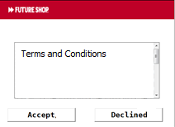

Figure : Terms and Conditions

#### Navigation/Menu Keys

| **Label** | **State** | **Next Screen** | **Notes** |
| --- | --- | --- | --- |
| Accept | Enabled | * If signature required, Continue to capture signature * If signature not required, return to calling use case with success | Text is configurable |
| Decline | Enabled | Display   * Terms & Conditions Not Accepted Message (section 0) and return to calling use case with not completed status |  |

#### Data/Input Field Enhancements

|  |  |  |  |  |  |  |
| --- | --- | --- | --- | --- | --- | --- |
| **Label** | **Editable** | **Req’d?** | **Data Type** | **Min**  **Length** | **Max**  **Length** | **Notes** |
| <Terms & Conditions> | No | N/A | N/A | N/A | N/A | Terms defined for the item |

### Terms and Conditions Signature Capture

Displays Signature Block for Customer to sign for Terms and Conditions.

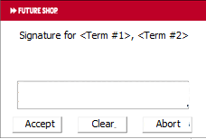

Figure : Terms and Conditions Signature Capture

#### Navigation/Menu Keys

| **Label** | **State** | **Next Screen** | **Notes** |
| --- | --- | --- | --- |
| Accept | See Note | * Signature capture does not meet minimum length or required data is missing: Invalid Signature Message (section 9.1.6.2). * Signature capture meets minimum length: calling use case | Enabled when an entry is made. |
| Clear | See Note | * Signature Capture | Enabled when an entry is made. |
| Abort | See Note | * Sale Use Case | None |

#### Data/Input Field Enhancements

|  |  |  |  |  |  |  |
| --- | --- | --- | --- | --- | --- | --- |
| **Label** | **Editable** | **Req’d?** | **Data Type** | **Min**  **Length** | **Max**  **Length** | **Notes** |
| <Signature Reason> | No | N/A | N/A | N/A | N/A | For each signature reason to be captured, the descriptive text for each signature is displayed on the line (for example ‘Transaction Tax Exempt’). If the signature reason is for an item, the item description is displayed with the Signature Reason (for example ‘Item Tax Exempt: Brand Laptop’). |
| Signature Line | Yes | Yes | N/A | See Notes | N/A | Database parameter to define the minimum data points allowed. |

### Tender Signature Capture

Displays Signature Block for Customer to sign for Tender.

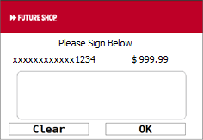

Figure : Tender Signature Capture

##### Navigation/Menu Keys

| **Label** | **State** | **Next Screen** | **Notes** |
| --- | --- | --- | --- |
| Enter | See Note | * Signature capture does not meet minimum length or required data is missing: Invalid Signature * Signature capture meets minimum length: calling use case | Enabled when an entry is made. |
| Clear | See Note | * Signature Capture | Enabled when an entry is made. |

##### Data/Input Field Enhancements

|  |  |  |  |  |  |  |
| --- | --- | --- | --- | --- | --- | --- |
| **Label** | **Editable** | **Req’d?** | **Data Type** | **Min**  **Length** | **Max**  **Length** | **Notes** |
| Signature | Yes | Yes | N/A | N/A | N/A | None |

# Printing

## Receipt Changes

Receipts defined in Receipt Generation Feature Document

# Configurable Settings

| **Parameter Mnemonic** | **Description** | **Valid Values** |
| --- | --- | --- |
| Signature Required | Determines if a function or an acceptance of Terms and Conditions requires a signature. The parameter also defines if the signature for a feature can be consolidated. | Current Scope:   * Warranty Item – PSP * Warranty Item – PRP * Item Tax Exempt * Tran Tax Exempt * Warranty Item – Monthly * Subscription Item * General Item Attribute for Signature Capture with Terms * Loyalty Enrollment * Finance Tender * Employee Sale |
| Prompt on PIN Pad | Determines if signature and terms & conditions should prompt on device or PIN Pad | * 0 or not defined – capture on device * 1 – capture on PIN Pad |
| Manual Signature Flag | Determines if manual signature is allowed. | * 0 or not defined – manual signature is not allowed * 1 – Manual signature is allowed. |
| Fail on Device Flag | Determines if fail on association to the PINPad should continue with capturing on device. | * 0 or not defined – do not capture on device * 1 – capture on device |

# Logging Changes

## Data Output

|  |  |  |
| --- | --- | --- |
| **Data Element** | **Description** | **Destination** |
| Terms and Conditions | The Terms and Conditions associated with the signature reason. | * E-Journal * Receipt |
| Signature | The signature captured from the customer. | * POSLog |
| Signature Reason | The reason details for the signature, such as Credit Tender. | * POSLog * E-Journal |

# Interface

Version 5.0 of Verifone form agent and XPIs.

# Out Of Scope

* *This Specification covers the changes needed to implement the changes for Signature Capture. Functionality that has no changes from the current processes is not covered unless needed to provide context.*

# Business Sign Off

|  |  |  |
| --- | --- | --- |
| **Name** | **Organization** | **Approval Email and/or Date Received** |
| Jesse Wielgan | Best Buy |  |

# Technical Sign Off

|  |  |  |
| --- | --- | --- |
| **Name** | **Organization** | **Approval Email and/or Date Received** |
| Kevin Bahng | Best Buy |  |
| Mark Houghton | Best Buy |  |

# Technical Review

|  |  |  |
| --- | --- | --- |
| **Name** | **Organization** | **Approval Email and/or Date Received** |
| Andy Liang | Best Buy |  |
| Greg Irvin | Best Buy |  |
| Anne Shetty | Best Buy |  |

# Technical Inform

|  |  |  |
| --- | --- | --- |
| **Name** | **Organization** | **Approval Email and/or Date Received** |
| Paul Leung | Storeworks/Stella Nova Technologies |  |
| Vinodh Narayanan | Storeworks/Stella Nova Technologies |  |
| Pete Gillis | Storeworks/Stella Nova Technologies |  |
| David Hawkins | Storeworks/Stella Nova Technologies |  |
| Muhammad Idriss | Storeworks/Stella Nova Technologies |  |

# Revision History

## Reviews

|  |  |  |
| --- | --- | --- |
| **Date** | **Iteration** | **Result** |
| 3/13/2015 | V1.3 – BBY – Jesse Review | Updates in V1.5 |
| 3/16/2015 | V1.3 – BBY – Mark Review | Updates in V1.5 |
| 3/19/2015 | V1.3 – BBY – Kevin Review | Updates in V1.5 |

## Revision History

| **Reviser** | **Revision** | **Date** | **Version** |
| --- | --- | --- | --- |
| Amy Lackas | Initial document created. This version includes the following changes: Added Employee Transaction, Finance Plan. | 07/16/2013 | 1.0 |
| Amy Byers | Corrected Heading to indicate capturing signature for Tender not Terms. | 10/6/2014 | 1.1 |
| Amy Byers | Added capturing terms acceptance and signatures on PINPad | 3/11/2015 | 1.2 |
| Amy Byers | Internal Review | 3/12/2015 | 1.3 |
| Amy Byers | Fixed Formatting issues | 3/13/2015 | 1.4 |
| Amy Byers | * Section 5.3: Clarified that PINPad busy is controlled by MRF. * Sections 6.1 & 6.4.4: Removed check for manual flag and prompt user to choose option. * Section 6.3: Removed ‘abort’ and replaced with a print option. * Sections 9.1.6.6 & 9.1.6.7: Added messages for tender to select retry, print or sign on device. * Section 13: Added verifone form agent & XPIs. * Section 20: Added section for referenced documentation. | 4/8/2015 | 1.5 |

# Referenced documentation

* Form name and Control ID_V3.xls sheets XPI Form V5 and FA Form V5,